Inequality Data Clinic
Session 2: Measuring inequality | Cambridge OCR A Level Sociology H580/02, Section B
Purpose
Students rotate around six data stations and identify: (1) the measure of inequality, (2) a clear pattern using evidence, and (3) one limitation of the indicator. The final task asks students to contrast income and wealth as measures of inequality.

Learning goals
- Identify how sociologists and official organisations measure inequality through income, wealth, occupation, education, housing and health data.
- Describe patterns accurately using comparative language and numerical evidence.
- Evaluate the usefulness and limitations of different indicators of inequality.
Teacher set-up
- Print Stations 1–6 as separate A4 pages and place them around the room. Keep the model answer until the plenary.
- Give each group one recording grid and one data-language support sheet. Allow approximately 6–8 minutes per station.
- After the rotation, use the comparison task to move from AO1 and AO2 into AO3. Students should explain why income and wealth are related but not interchangeable measures.
What is included
- Six A4 data panels: income, wealth, occupation, education, housing and health.
- Measure–pattern–limitation recording grid.
- Data-language support sheet.
- Completed model answer contrasting income and wealth.
Important data note
These panels use official UK/England data from different reference periods. Students should not compare the size of every number across different panels; each panel is designed to show how one indicator can reveal an aspect of social inequality.

Student Recording Grid
Use one row for each station. Write evidence as a statistic or a precise comparison.
Station / indicator | What does the indicator measure? | One numerical pattern | A second pattern or comparison | One limitation / question
1. Income
2. Wealth
3. Occupation
4. Education
5. Housing
6. Health
Final comparison task
Using the income and wealth stations, write a developed paragraph answering the question below:
Question
Explain one difference between income and wealth as measures of inequality. Use at least two statistics and include one limitation of either measure.

Data-Language Support Sheet
Use these sentence starters to turn a statistic into a sociological point.
1. Name the measure (AO1)
- This indicator measures …
- The data are based on …
- A Gini coefficient is used to show …
- This is a measure of inequality because …
2. Describe a pattern (AO2)
- The clearest pattern is that …
- There is a gap of … percentage points / years / pounds between … and …
- Compared with …, … is higher/lower by …
- This suggests that inequality is linked to …
- The pattern is not evenly distributed because …
3. Evaluate the indicator (AO3)
- However, this measure does not show …
- A limitation is that the data are collected at household / area / occupational level, so …
- The figures show an association, but they cannot prove that … causes …
- The categories may hide differences within the group because …
- A fuller picture would combine this with evidence on …
Useful comparison vocabulary
Comparative words
higher • lower • more unequal • less unequal • gap • disparity • concentration • distribution • relative disadvantage • life chances • deprivation • occupational inequality • material inequality

Quick reminder: describe, then explain
Weak: “There is inequality in housing.”
Stronger: “Private renters in the lowest income quintile spent 63% of their household income on rent, compared with 17% among higher-income private renters. This indicates that housing costs place a much heavier burden on lower-income households.”

STATION 1
Income inequality
Income is a flow of money received over a period of time, for example from wages, benefits, pensions or investments.
What is being measured?
The panel uses the Gini coefficient to compare how equally income is distributed. A lower Gini coefficient indicates a more equal distribution.

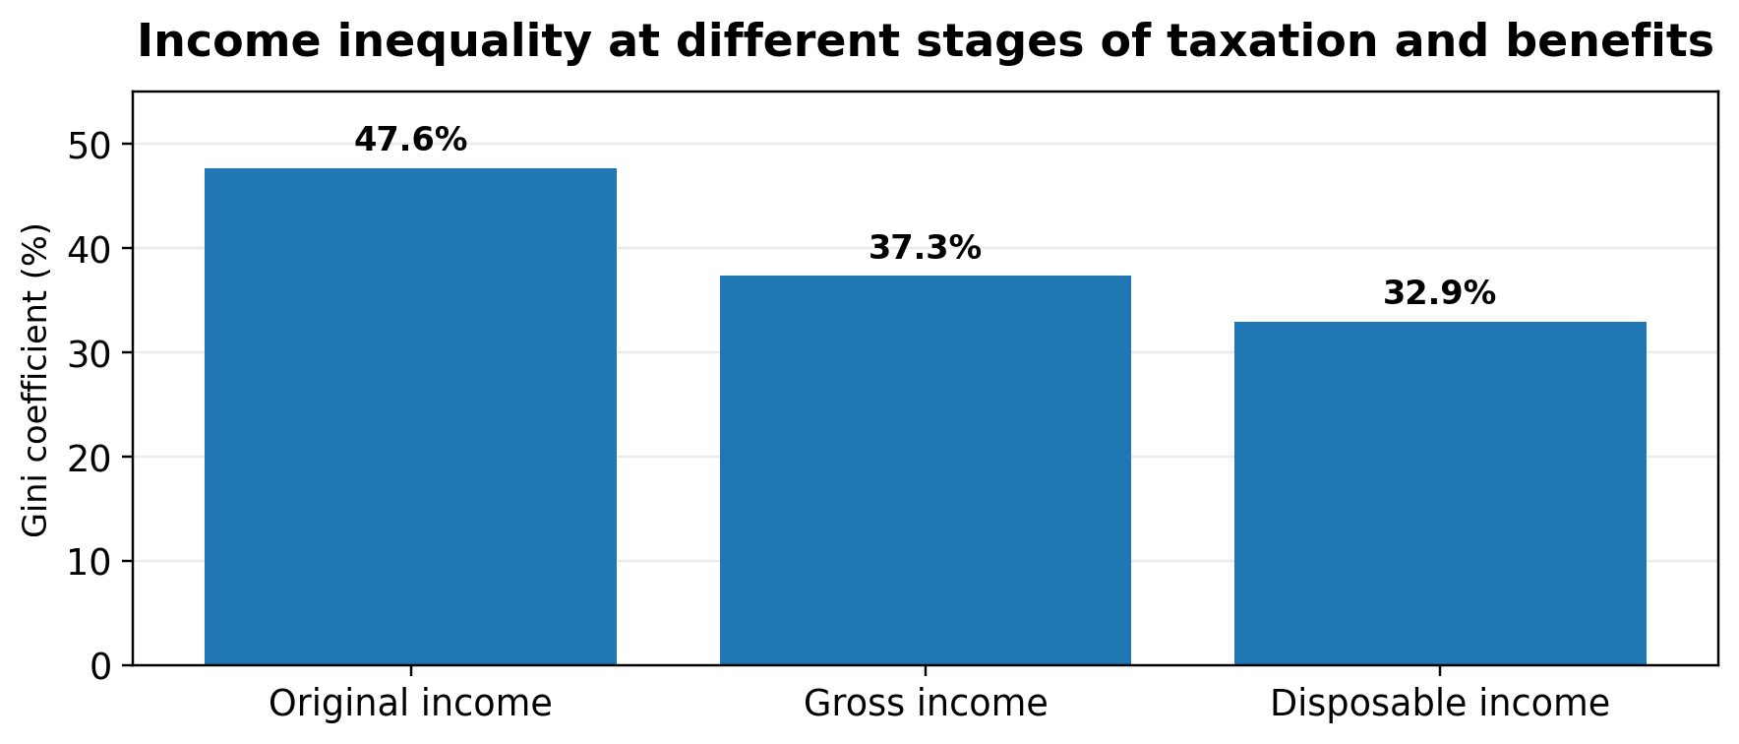
Data snapshot
- Original income inequality was 47.6% in the UK in FYE 2024.
- After cash benefits are included, gross income inequality was lower: 37.3%.
- After direct taxes and benefits, disposable income inequality was 32.9%.
At this station, record:
- The exact income measure being used.
- Two patterns, including one comparison between stages.
- One reason why income alone may not show the full picture of inequality.
A possible limitation to consider
A Gini coefficient summarises the whole distribution in one figure. It does not show which social groups have gained or lost, nor does it include differences in wealth, debt or local living costs.
Source: Office for National Statistics, Household income inequality, UK: FYE 2024

STATION 2
Wealth inequality
Wealth is the stock of assets a household owns, minus debts. It can include property, savings, pensions, investments and physical possessions.
What is being measured?
The panel compares household wealth at different points in the distribution. Unlike income, wealth can be passed between generations through inheritance or help with housing.

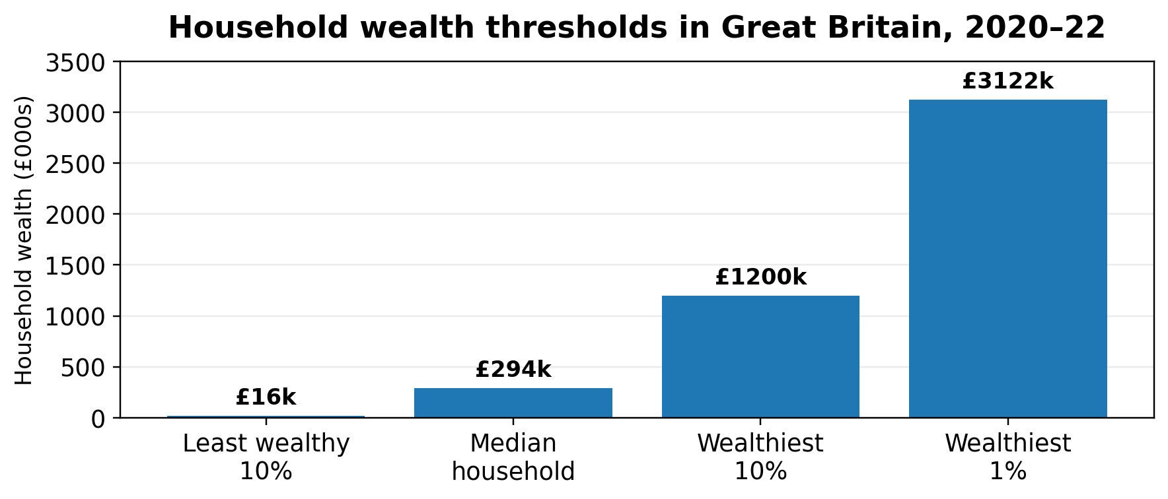
Data snapshot
- Median household wealth in Great Britain was £293,700 (April 2020–March 2022).
- The wealthiest 10% of households had £1,200,500 or more, while the least wealthy 10% had £16,500 or less.
- The wealthiest 1% held 10% of all household wealth: the same share as the least wealthy 50% combined.
- The wealth Gini coefficient was 0.59, compared with 0.36 for disposable income in FYE 2022.
At this station, record:
- The difference between wealth and income.
- Two patterns using exact figures.
- Why wealth may be more concentrated than income.
A possible limitation to consider
This is household-level data, so it cannot show how wealth is shared within households. The data were also collected during the pandemic and changes to pension methodology mean comparisons over time require care.
Source: Office for National Statistics, Household total wealth in Great Britain: April 2020 to March 2022

STATION 3
Occupation and low pay
Occupation is used as an indicator of social position because jobs differ in earnings, security, autonomy, status and opportunities for progression.
What is being measured?
This panel uses the proportion of employee jobs paid below two-thirds of median hourly earnings. The Office for National Statistics defines this as low pay.

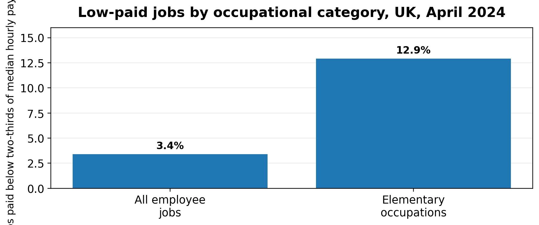
Data snapshot
- In April 2024, 3.4% of all employee jobs were low-paid.
- In elementary occupations, 12.9% of jobs were low-paid.
- Elementary occupations include jobs such as cleaners and delivery drivers.
- Low pay was also more common among workers aged 16–21 (36.1%) and among women (3.9%, compared with 2.8% of men).
At this station, record:
- The occupational measure being used.
- One pattern between elementary occupations and all jobs.
- One way occupation overlaps with gender or age inequality.
A possible limitation to consider
This measure focuses on pay. It does not directly show job security, unpaid work, self-employment, workplace power or differences within broad occupational categories.
Source: Office for National Statistics, Low and high pay in the UK: 2024

STATION 4
Educational inequality
Educational attainment can be used as an indicator of inequality because qualifications affect later access to higher education, employment and income.
What is being measured?
This panel compares the proportion of disadvantaged pupils and other pupils who achieved grade 5 or above in both GCSE English and maths in England.

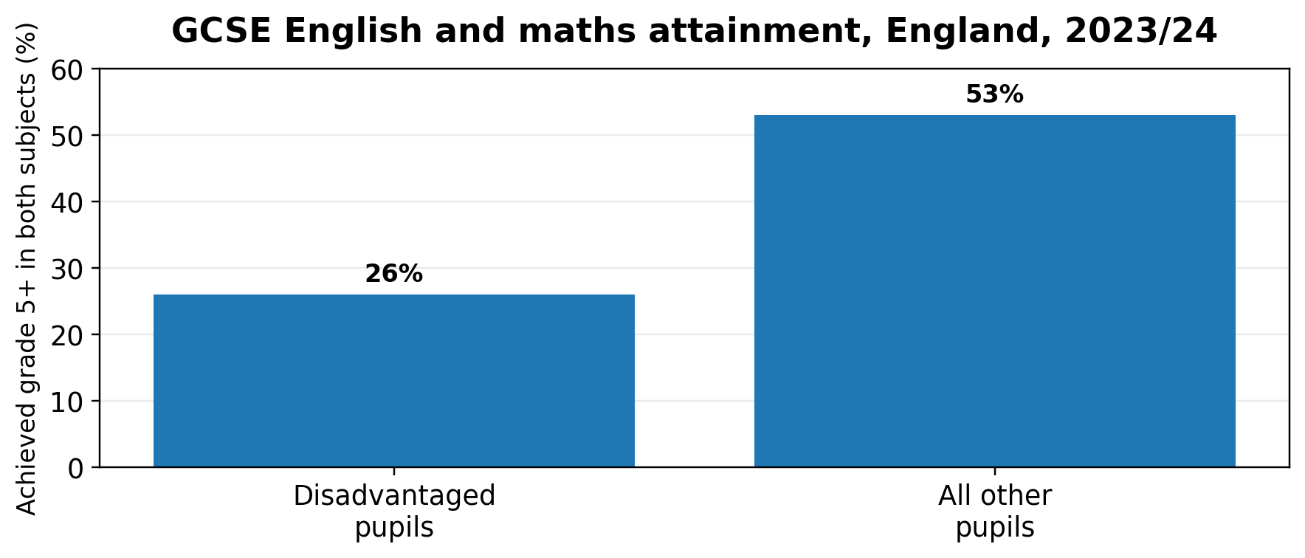
Data snapshot
- In the 2023/24 school year, 26% of disadvantaged pupils achieved grade 5 or above in both GCSE English and maths.
- Among all other pupils, 53% reached the same threshold.
- This is a gap of 27 percentage points.
At this station, record:
- The educational outcome being measured.
- The size of the attainment gap.
- Why attainment data might matter for later life chances.
A possible limitation to consider
A single GCSE threshold does not capture every form of educational success, progress during school, vocational attainment or the different experiences within the category “disadvantaged”. It also cannot, by itself, prove why the gap exists.
Source: Social Mobility Commission, State of the Nation 2025: attainment at age 16 (using DfE data for 2023/24)

STATION 5
Housing inequality
Housing inequality can be measured through affordability, tenure, quality, overcrowding, security and access to home ownership.
What is being measured?
This panel measures the share of gross household income spent on rent by private renters in different income quintiles in England.

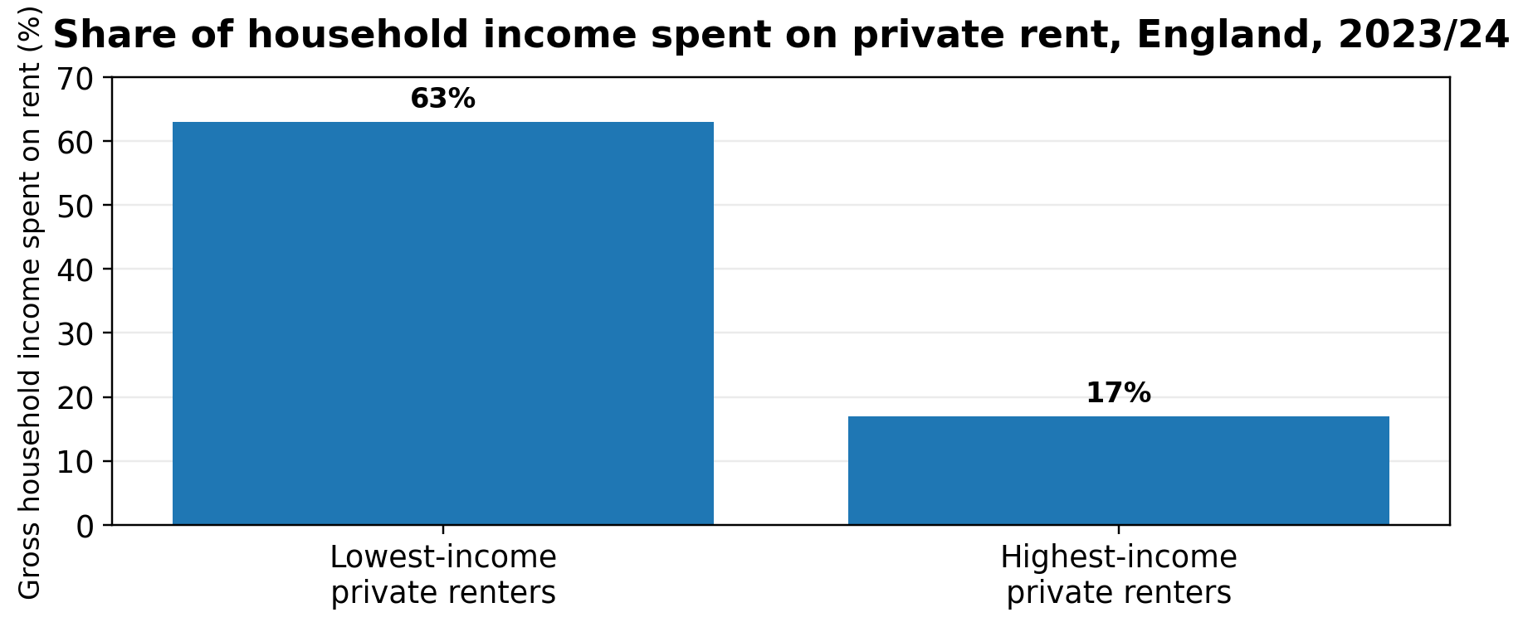
Data snapshot
- Private renters in the lowest income quintile spent 63% of household income on rent in 2023/24.
- Private renters in the highest income quintile spent 17% of income on rent.
- Across all private renters, the average housing-cost share was 34%.
- 71% of lower-income private renters spent more than 30% of income on rent.
At this station, record:
- The housing affordability measure.
- A comparison between low- and high-income renters.
- One way housing costs could affect other life chances.
A possible limitation to consider
The calculation is based on gross household income, including benefits, and assumes household members contribute to housing costs. It is England-only and does not directly measure housing quality, overcrowding or homelessness.
Source: Ministry of Housing, Communities and Local Government, English Housing Survey 2023 to 2024: experiences of the housing crisis

STATION 6
Health inequality
Healthy life expectancy estimates the number of years people can expect to live in “good” general health. It is a life-chances measure rather than simply a measure of length of life.
What is being measured?
This panel compares healthy life expectancy at birth in the most and least deprived areas of England. Deprivation is measured at area level.

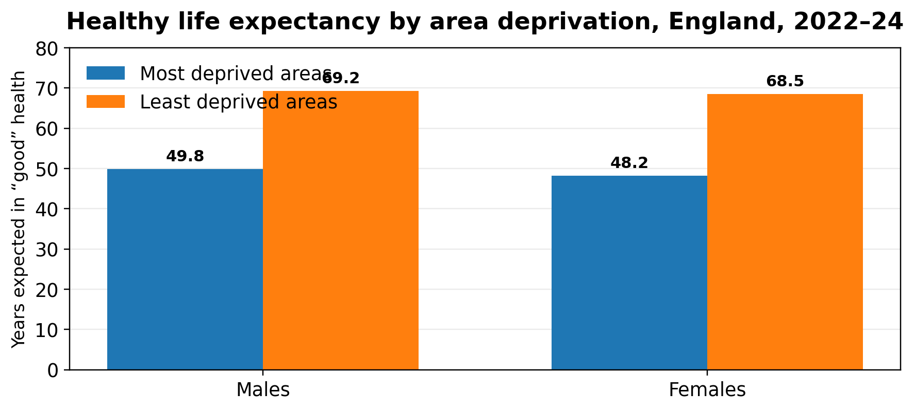
Data snapshot
- In 2022–24, males in the most deprived areas could expect 49.8 years in good health, compared with 69.2 years in the least deprived areas.
- For females, the equivalent figures were 48.2 years and 68.5 years.
- The gap in healthy life expectancy was therefore around 19 years for males and 20 years for females.
At this station, record:
- The health outcome being measured.
- A comparison between deprivation groups.
- Why health inequalities demonstrate unequal life chances.
A possible limitation to consider
Area deprivation is not the same as an individual’s social class or income. Healthy life expectancy is an average estimate and cannot identify the precise causes of health inequality for particular individuals or communities.
Source: Office for National Statistics, Healthy life expectancy by national area deprivation, England and Wales: 2022 to 2024

Teacher Resource: Completed Model Answer
Use after the data clinic. This models concise AO1, AO2 and AO3 rather than a full essay.
Question
Explain one difference between income and wealth as measures of inequality. Use at least two statistics and include one limitation of either measure.

Model response
Income and wealth are both measures of economic inequality, but they measure different things. Income is the money received over a period of time through sources such as wages, benefits, pensions and investments. Wealth is the stock of assets a household owns, minus its debts. It includes property, savings and pension wealth. This means a household may have a high income but little wealth, for example if it rents privately and has little savings. Equally, a retired household may have a relatively modest current income but substantial property or pension wealth. The income data show that taxes and benefits reduce, but do not remove, inequality. The Gini coefficient for original income was 47.6% in FYE 2024, compared with 32.9% for disposable income after direct taxes and benefits. This suggests that state redistribution makes income more equal. However, the Gini coefficient is a summary figure: it does not show which groups hold the highest incomes or how living costs vary between households. Wealth is more concentrated than income. Between 2020 and 2022, the wealthiest 10% of households had at least £1,200,500 in wealth, whereas the least wealthy 10% had £16,500 or less. The wealthiest 1% held the same share of total household wealth as the least wealthy 50% combined. Wealth is therefore a particularly useful measure for showing long-term inequality because assets can generate further income and can be inherited. However, household wealth data may conceal inequalities within a household, such as unequal access to savings or pensions between partners. Overall, income is useful for showing people’s day-to-day material resources, while wealth is more useful for identifying accumulated advantage, security and the ability to pass resources between generations. A fuller account of inequality should use both measures together.
Why this works
- AO1: accurately distinguishes income from wealth and uses the Gini coefficient correctly.
- AO2: uses numerical evidence from the panels to support the explanation.
- AO3: evaluates both measures by considering what each one cannot show, then reaches a justified comparison.

Teacher Resource: Station Answer Guide
These are indicative answers. Accept any well-supported alternative limitation.
Station | Indicative answer
Income | Measure: distribution of income using Gini coefficients at original, gross and disposable stages. Patterns: inequality is highest before taxes/benefits (47.6%) and lower after them (32.9%); redistribution reduces inequality. Limitation: Gini does not reveal who is unequal or local living-cost differences.
Wealth | Measure: household assets minus debts, including property and pensions. Patterns: top 10% have £1.2m+ vs bottom 10% £16.5k or less; top 1% holds same 10% share as bottom 50%. Limitation: household-level data and pandemic/method changes make some comparisons difficult.
Occupation | Measure: proportion of jobs below two-thirds of median hourly pay. Patterns: elementary occupations 12.9% low-paid vs 3.4% overall; overlaps with age and gender. Limitation: pay alone cannot show job security, status or unpaid labour.
Education | Measure: proportion achieving grade 5+ in both English and maths. Patterns: 26% disadvantaged vs 53% other pupils; 27-point gap. Limitation: one threshold cannot capture wider learning/progress or explain causes.
Housing | Measure: housing costs as share of gross household income. Patterns: lower-income private renters 63% vs high-income 17%; 71% lower-income private renters spend 30%+ of income on rent. Limitation: England-only, assumes household income is shared and does not show quality.
Health | Measure: healthy life expectancy by area deprivation. Patterns: male gap 19.4 years and female gap 20.3 years; most deprived groups spend fewer years in good health. Limitation: area deprivation does not equal individual class/income; averages cannot show individual causes.

Source and Reference List
All figures are reproduced or adapted from official data releases. Use the linked titles to access the full statistical releases.
Income: Office for National Statistics. Household income inequality, UK: financial year ending 2024. Released 2 May 2025.
Wealth: Office for National Statistics. Household total wealth in Great Britain: April 2020 to March 2022. Released 24 January 2025.
Occupation: Office for National Statistics. Low and high pay in the UK: 2024. Released 29 October 2024.
Education: Social Mobility Commission. State of the Nation 2025: attainment at age 16 (data for the 2023/24 school year).
Housing: Ministry of Housing, Communities and Local Government. English Housing Survey 2023 to 2024: experiences of the housing crisis. Released 15 May 2025.
Health: Office for National Statistics. Healthy life expectancy by national area deprivation, England and Wales: 2022 to 2024. Released 15 April 2026.
Cambridge OCR context
The Cambridge OCR Suggested Studies Guide lists evidence on social class, gender, ethnicity and age as relevant for the “patterns and trends” question, and makes clear that appropriate evidence can include statistical patterns and trends, concepts and examples, as well as research studies.
Suggested extension: students identify which panel most clearly evidences class inequality and which panels also show intersections with gender, ethnicity or age.

